AWS Batch Service
AWS Batch helps you to run batch computing workloads on the AWS Cloud. This service can efficiently provision resources in response to jobs submitted in order to eliminate capacity constraints, reduce compute costs, and deliver results quickly.
As a fully managed service, AWS Batch helps you to run batch computing workloads of any scale. AWS Batch automatically provisions compute resources and optimizes the workload distribution based on the quantity and scale of the workloads. With AWS Batch, there's no need to install or manage batch computing software, so you can focus your time on analyzing results and solving problems.

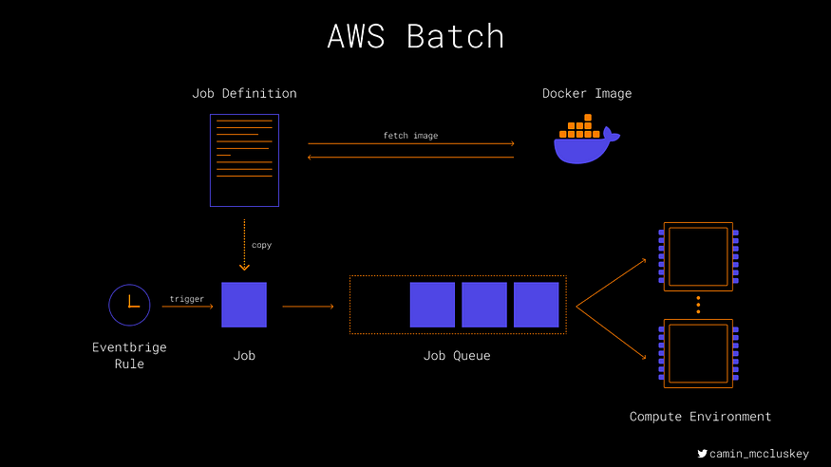
- Job: an actual unit of computation. Jobs specify what job definition they inherit from, and they are pushed into a job queue.
- Job Definition: describes a template for a job. Here you define the image that represents the container that will run, the role passed to that container, the compute type (EC2 or Fargate) and any environment variables (plus much more optional configuration).
- Job Queue: holds the jobs that are ready to be processed by the next available compute resource. Queues specify what compute environments they want their jobs to run in (can be multiple in some order).
- Compute Environment: Represents the actual compute resource that the job could run in.

Pre-Requisite
- Docker image pushed to ECR.
A simple Dockerfile for a Python job will look something like the following:
FROM python:3

COPY requirements.txt ./
COPY config.py ./
RUN pip3 install -r requirements.txt
COPY file_transfer_gcash.py ./

ENTRYPOINT [ "python", "file_transfer_gcash.py" ]

In this Docker file you are copying the dependency requirements file and the “config.py” file which contains variable definition into a Docker image and installing the dependencies. Finally, you are specifying that the container should start by running the “file_transfer_gcash.py” script.

Create an ECR Repository and Push the Image
You will use AWS Elastic Container Registry (ECR) to host your image. Go to ECR in the AWS console and click create repository. You most likely want a private repository, and you may want to name it with the following convention: <batch-job-name>-repo
You now need to push the Docker image to the ECR repository. You can do this manually from your terminal.
Run the following 4 commands, replacing the AWS region with the region where your ECR repo is hosted, the profile with the name of a named AWS profile (required only if you have more than 1 profile), and the AWS account number. You will need the aws-cli installed on your machine.
$ aws ecr get-login-password --region <aws-region> --profile <named-profile-with-ecr-access> | docker login --username AWS --password-stdin <aws-account-number>.dkr.ecr.<aws-region>.amazonaws.com

$ docker build -t <your-image-name> .

$ docker tag <your-image-name>:latest <aws-account-number>.dkr.ecr.<aws-region>.amazonaws.com/<ecr-repo-name>:latest

$ docker push <aws-account-number>.dkr.ecr.<aws-region>.amazonaws.com/<ecr-repo-name>:latest

AWS Batch Job Setup
You can follow the AWS Batch Wizard. The steps below are the same as the wizard.

Select Orchestration type.
Chose the orchestration type as Amazon Elastic Compute Cloud (EC2) and click Next.
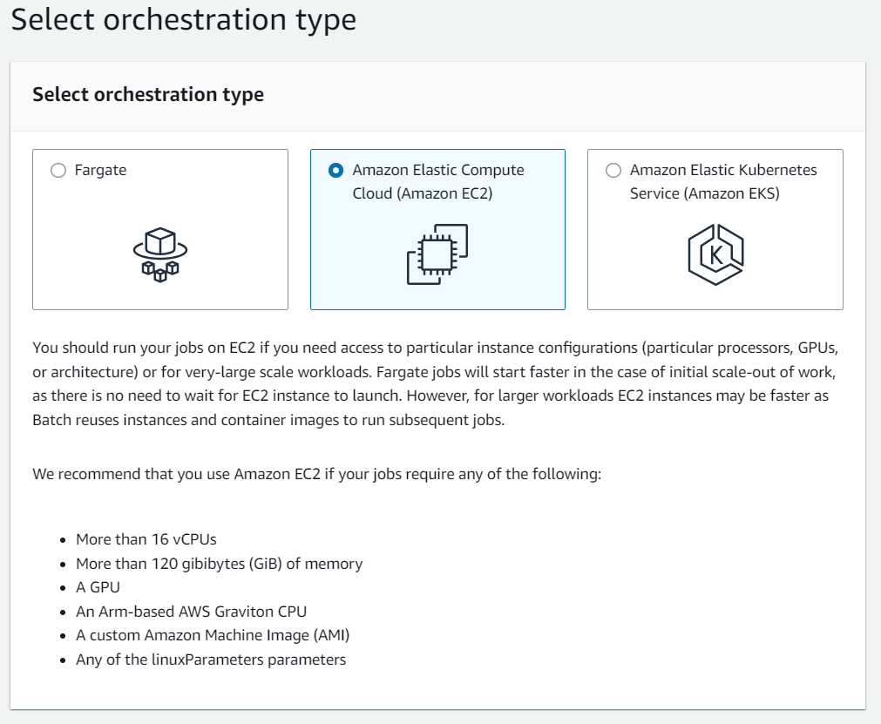

Create Compute Environment
Compute environments contain the Amazon ECS container instances that are used to run containerized batch jobs. A specific compute environment can also be mapped to one or more than one job queue. Within a job queue, the associated compute environments each have an order that's used by the scheduler to determine where jobs that are ready to be run will run. If the first compute environment has a status of VALID and has available resources, the job is scheduled to a container instance within that compute environment. If the first compute environment has a status of INVALID or can't provide a suitable compute resource, the scheduler attempts to run the job on the next compute environment.
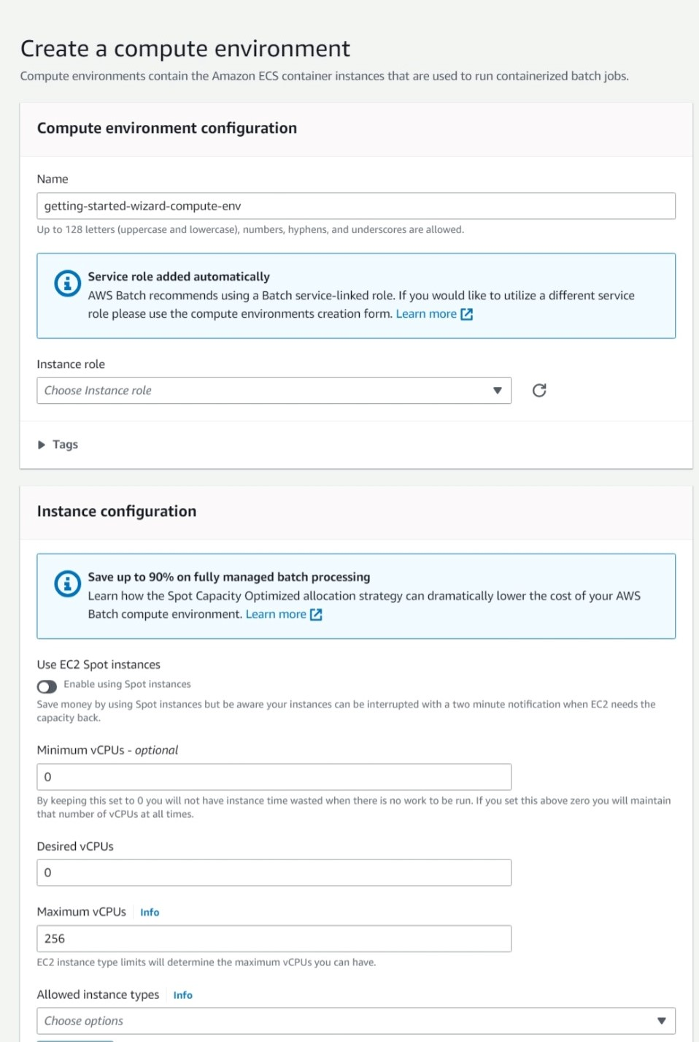
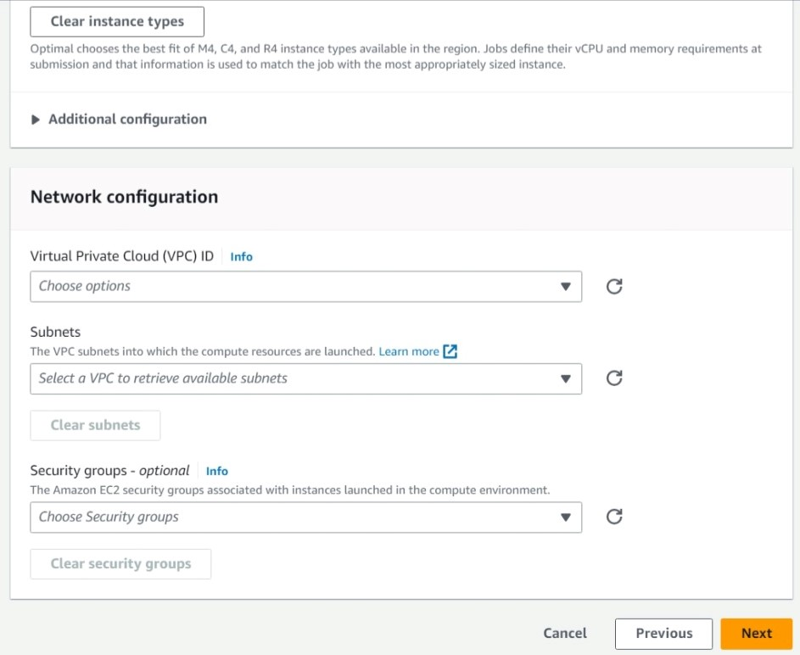

Create Job Queue
Jobs are submitted to a job queue where they reside until they can be scheduled to run in a compute environment. An AWS account can have multiple job queues. For example, you can create a queue that uses Amazon EC2 On-Demand instances for high priority jobs and another queue that uses Amazon EC2 Spot Instances for low-priority jobs. Job queues have a priority that's used by the scheduler to determine which jobs in which queue should be evaluated for execution first.
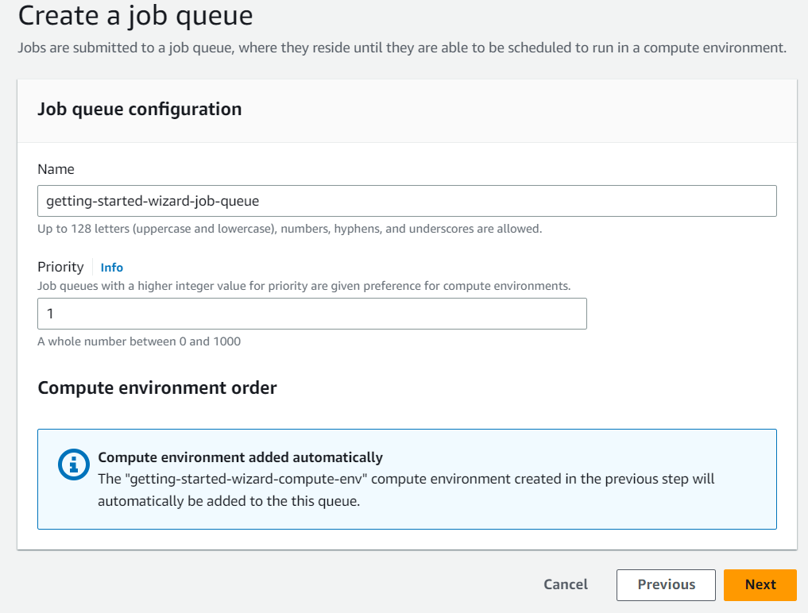

Create Job Definition
A job definition specifies how jobs are to be run. You can think of a job definition as a blueprint for the resources in your job. You can supply your job with an IAM role to provide access to other AWS resources. You also specify both memory and CPU requirements. The job definition can also control container properties, environment variables, and mount points for persistent storage. Many of the specifications in a job definition can be overridden by specifying new values when submitting individual Jobs. Some of the attributes specified in a job definition include:
- Which Docker image to use with the container in your job
- How many vCPUs and how much memory to use with the container.
- The command the container should run when it is started.
- What (if any) environment variables should be passed to the container when it starts
- Any data volumes that should be used with the container.
- What (if any) IAM role your job should use for AWS permissions

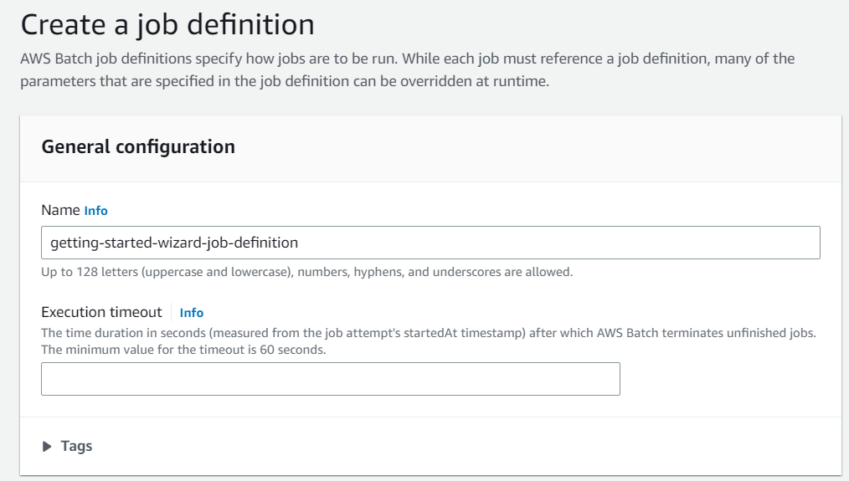
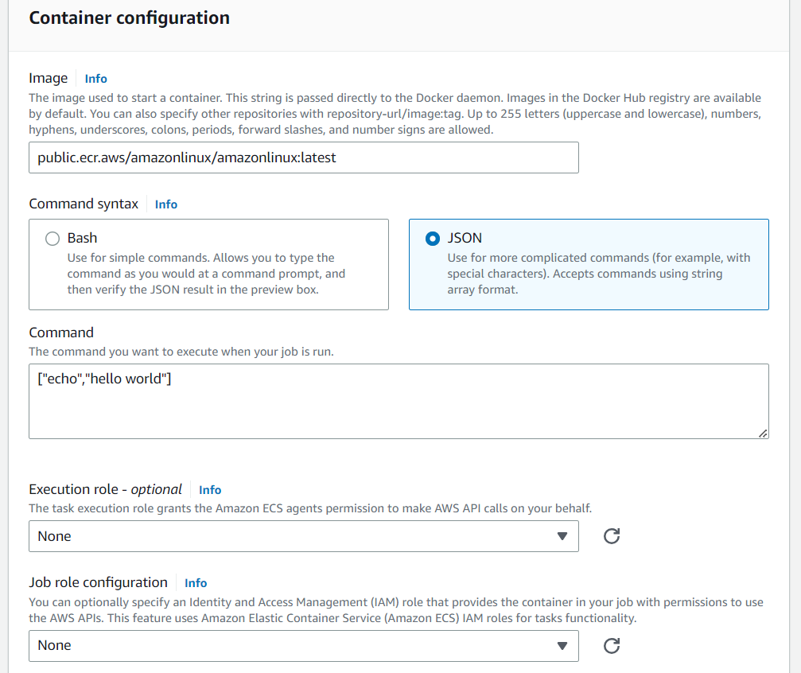
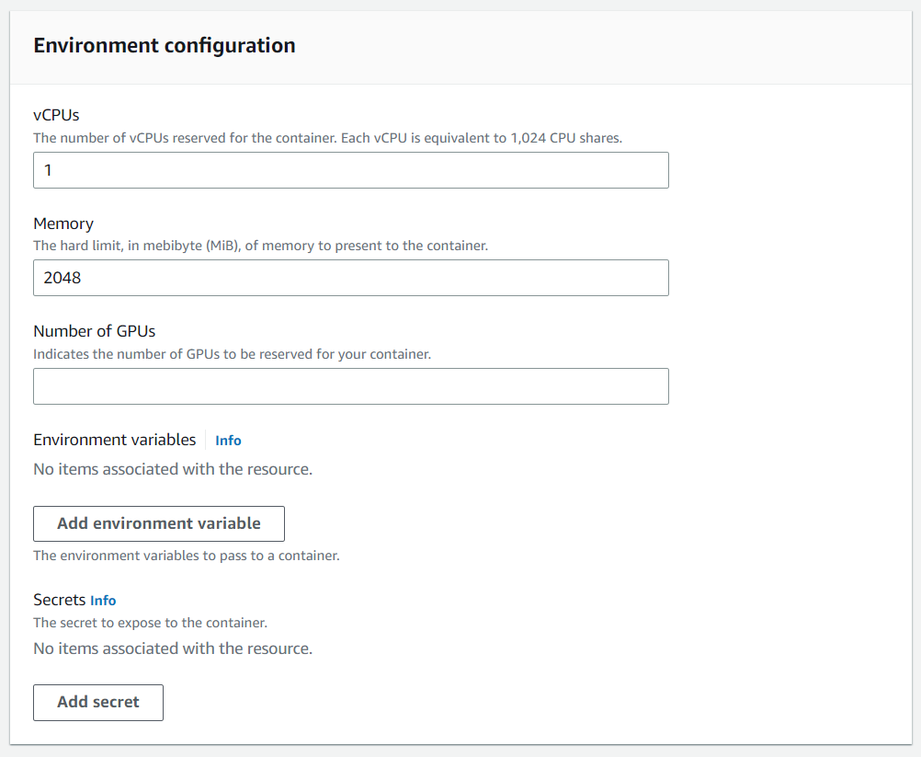
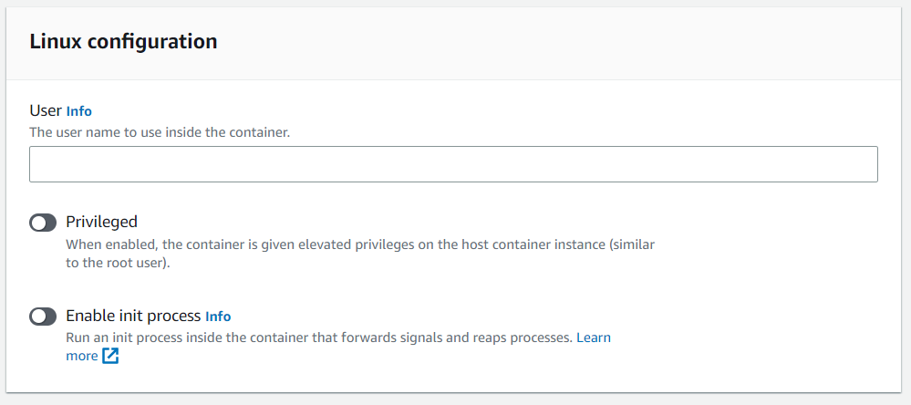
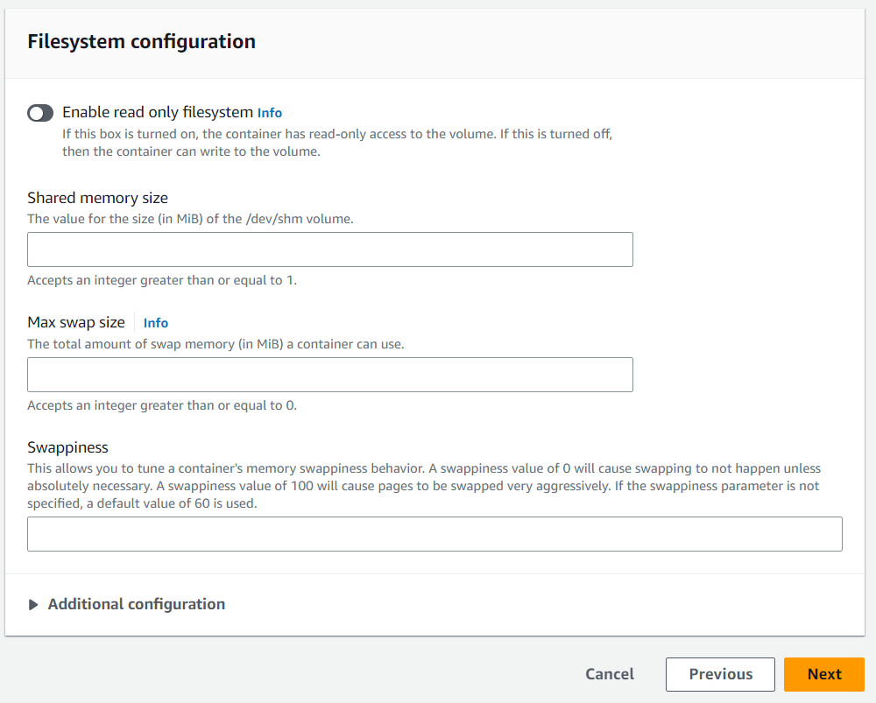

Create Job
A unit of work (such as a shell script, a Linux executable, or a Docker container image) that you submit to AWS Batch. It has a name, and runs as a containerized application on AWS Fargate or Amazon EC2 resources in your compute environment, using parameters that you specify in a job definition. Jobs can reference other jobs by name or by ID, and can be dependent on the successful completion of other jobs.
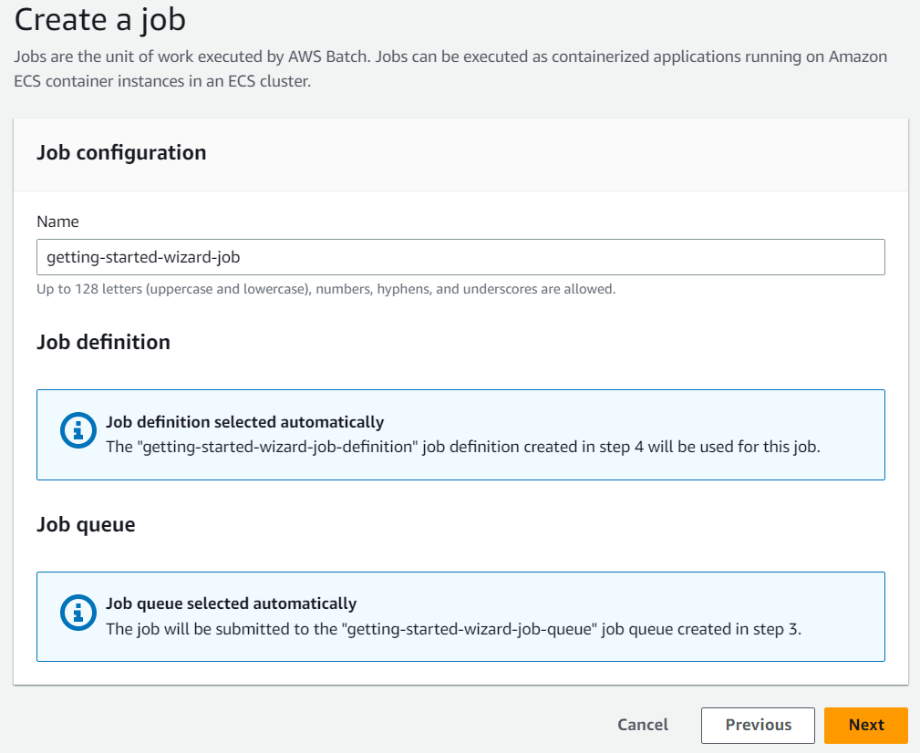

AWS Schedule Cron job
  - Create a rule in cloud watch -> Events -> Rules -> Create Rule and select Schedule and click on Continue to create rule.
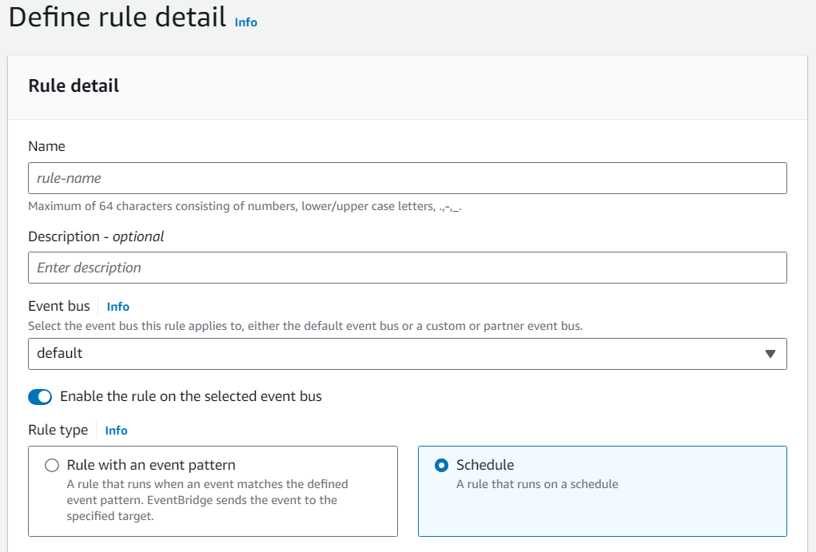
  - Define the Cron Expression
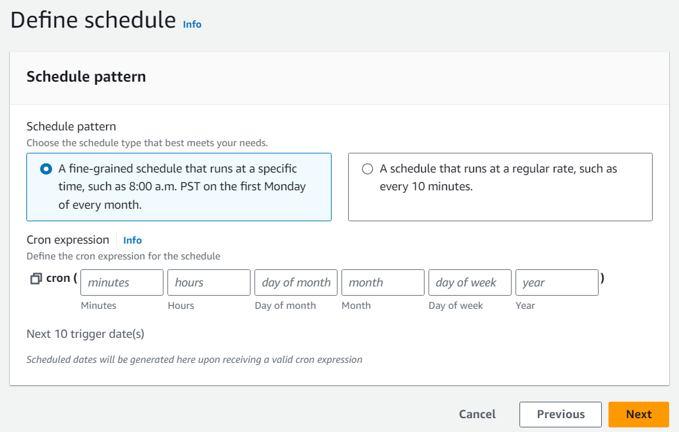
  - Select the Target and add the Job Definition and Job queue ARN.
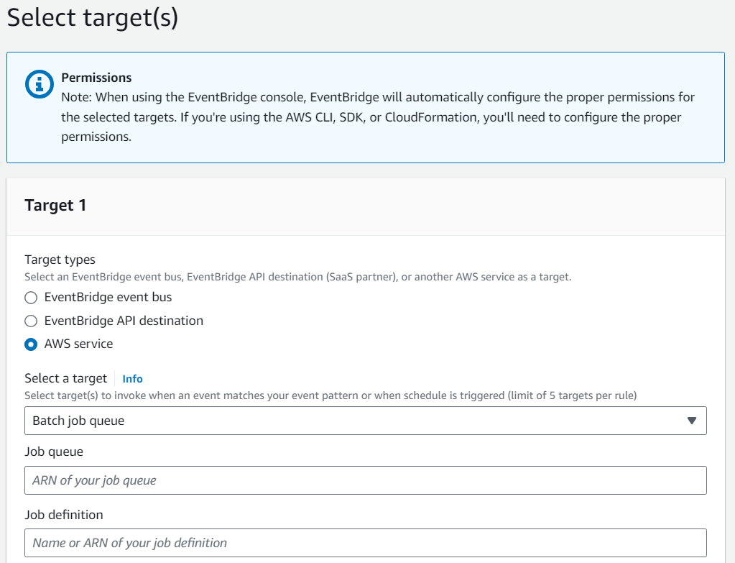
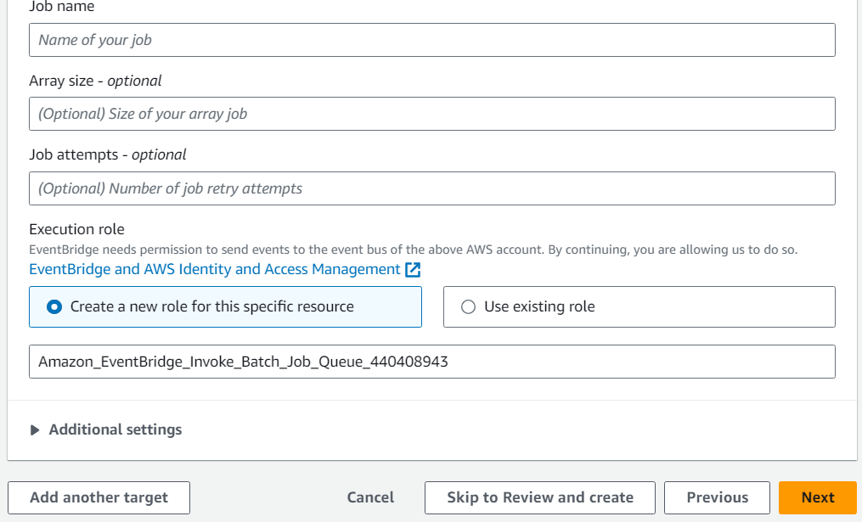
  - Configure Tags if required.
  - Review and Create Rule.

